Assignment 4

Nicholas Colonna

4/21/2018

## Problem 2

#2c  
#phi0=0.001, phi1=0.5, phi2=0.3, rt=0.015, rt-1=0.005 var=0.0001  
  
sum <- 0  
for(i in 1:1000){  
 rs <- c(0.005, 0.015) #(rt-1, rt)  
 a <- rnorm(1, 0, sqrt(0.0001))  
 for(j in 1:2){ #generates next 2 values, making rs<-(rt-1, rt, rt+1, rt+2)  
 rs <- c(rs, 0.001+0.5*rs[j+1]+0.3*rs[j]+a)  
 }  
 sum <- sum + rs[4] #adds only the term for rt+2 to the sum variable  
}

avgRp2 <- sum / 1000  
avgRp2

## [1] 0.01051579

#2d  
ts <- c(0.005, 0.015)  
for(i in 1:2000){ #iterates to generate timeseries, starting at rt+1 and ending at rt+2000  
 at <- rnorm(1, 0, sqrt(0.0001))  
 ts <- c(ts, 0.001+0.5*ts[i+1]+0.3*ts[i]+at)  
}

summary(ts)

## Min. 1st Qu. Median Mean 3rd Qu. Max.   
## -0.045140 -0.005756 0.005772 0.005333 0.016300 0.055830

#2e  
pacf(ts, lag.max=15)

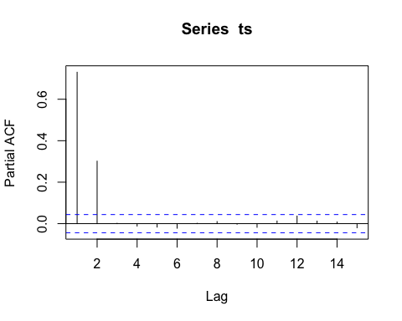

# Given the results of the PACF, the recommended AR order is 2

#2f  
ar2model <- ar(ts, method="mle")  
ar2model$ar

## [1] 0.5098432 0.3014436

ar2model$var.pred

## [1] 0.0001063846

# These parameter do a pretty good job approximating the real parameter values. The real parameters are phi1=0.5, phi2=0.3, and var=0.0001. The estimated parameters were phi1=0.50984, phi2=0.30144, and var=0.0001064, which are very close to the actual values.